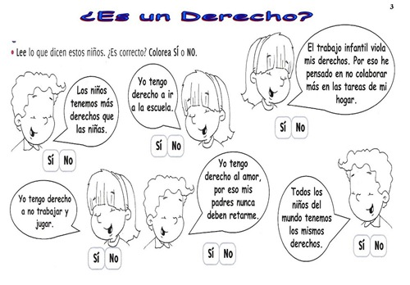Nombre: ______________________________________________________________________

